Independent Academic Path Optimizer

User Manual

AI-Assisted Class Scheduling Application



Document Type | User Manual
Project | Independent Academic Path Optimizer
Course Deliverable | CS691 Sprint 2 Final Application
Version | v1.0.0
App URL | https://2026-paceu-capstone.github.io/intelligent-academic-path-optimizer
Prepared Date | August 2026

Revision History

Version | Date | Description
v1.0.0 | August 2026 | Initial user manual for Sprint 2 Wiki Submission

Table of Contents
- Introduction
- Device Requirements
- Registering or Logging In
- Entering Your Data
- Uploading Your Transcript
- Specify What You’re Looking For
- Schedule Page
- Settings Page
- Light and Dark Mode
- Contact Page

1. Introduction
This manual is intended for students and staff who are looking to use the Intelligent Academic Path Optimizer (IAPO) to plan out the next steps in one’s education. The IAPO is a web application that allows a user to input information on one’s educational journey and receive a path forward tailored to their interests. This may be useful to not only students, but advisors and administrators for an overarching view of the curriculum.

2. Device Requirements
This application will run optimally on most up to date browsers such as Google Chrome, Safari, or Firefox. Additionally Cross-Site Traffic must be enabled on the browsers, allowing session login cookies to be saved. A personal computer is suggested for best rendering and ease of use. If submitting a transcript, conversion to a PDF is necessary. Many popular word processors will allow you to export your DOCX or PAGES file to a PDF.

3. Registering or Logging In
Begin by accessing the website via: https://2026-paceu-capstone.github.io/intelligent-academic-path-optimizer.

You will see the home page with options to either sign up or log in, as follows:

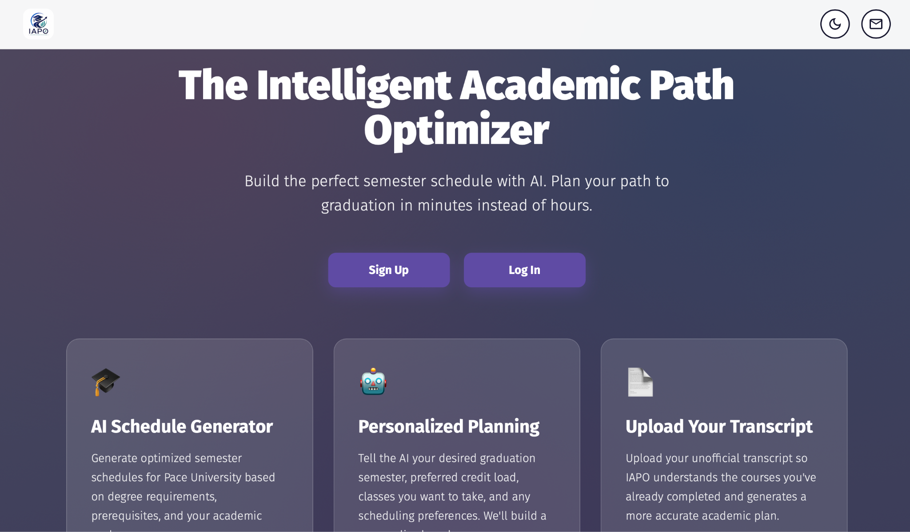

If this is the first time using the site, proceed with the Sign Up button, otherwise click Log In.

Signing Up
To sign up, enter a valid email and strong password that is at least 8 characters and includes a capital letter, a number, and a special character.
Logging In
To log in, enter your email and password. Upon successful log in, the user will be taken back to the home page with access to their profile and schedule. Once logged in, the user may view the schedule page again at any time by clicking their initial in the top right of the screen.


At any point the user may click the IAPO logo next to it to navigate back to the home page.

Note:
Email and password may be edited later. See section 8 for more information.

4. Entering Your Data
To ensure a schedule is optimally created based on the user’s needs, some information is required. The form will ask that the user fills out their:
- Name
- Educational level
- Major
- Beginning and ending semester
- Credit per semester desired

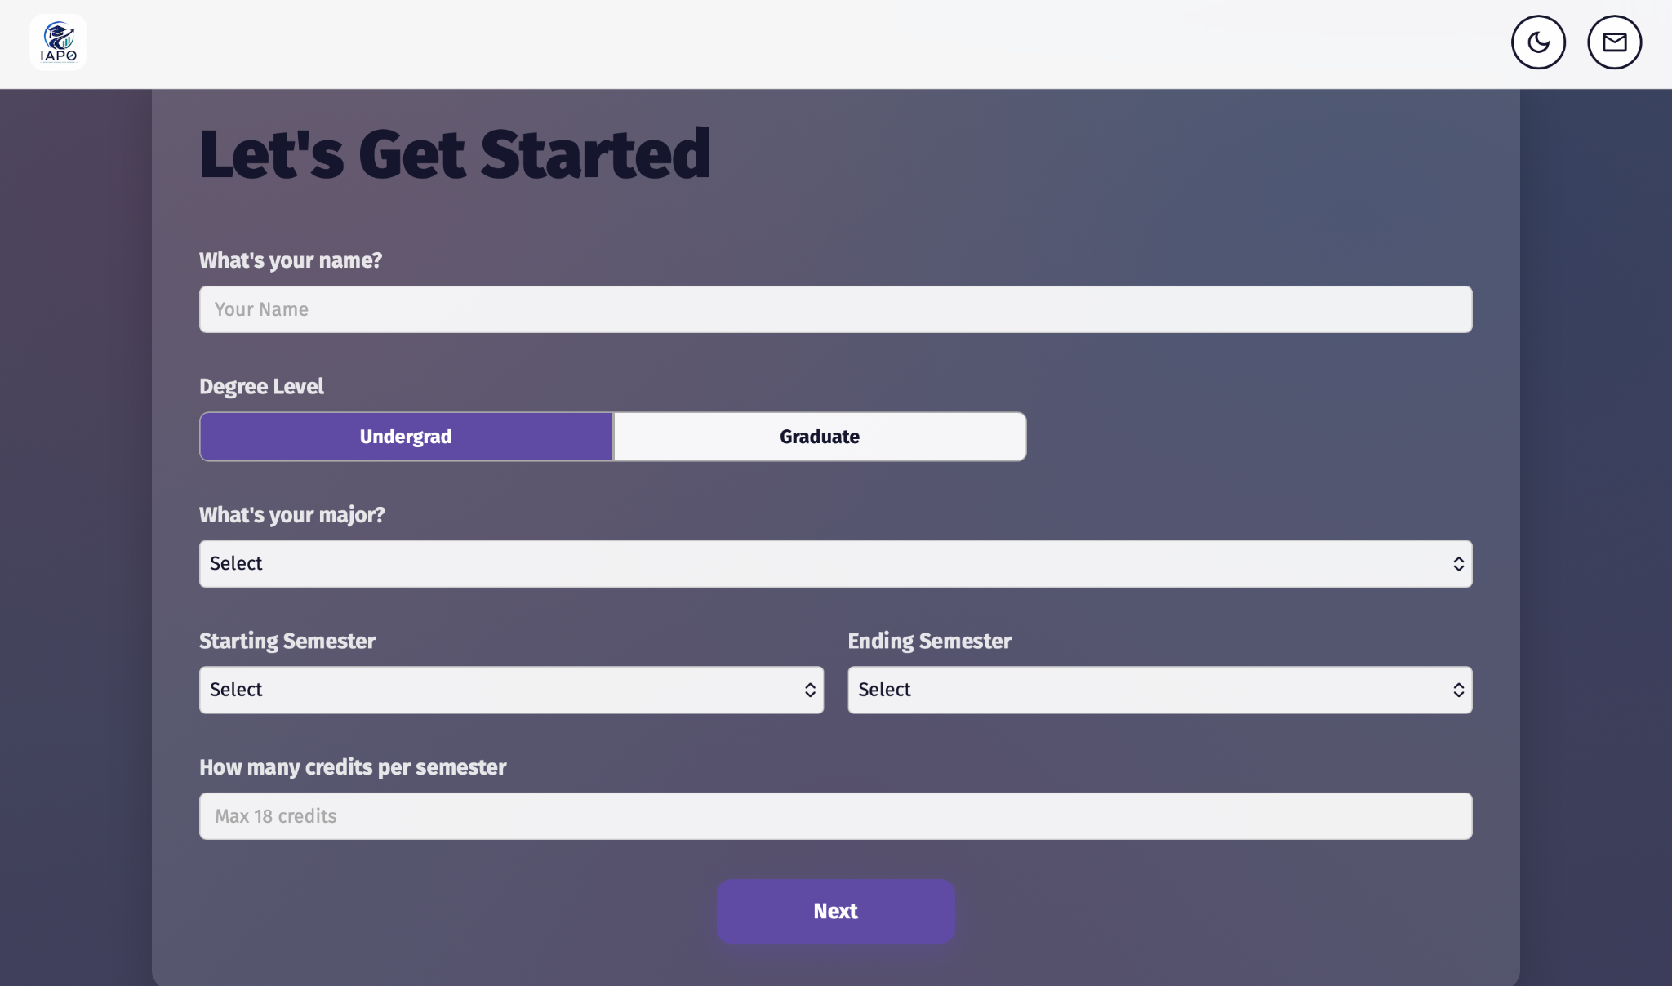

Click Next to proceed with profile creation.

5. Uploading Your Transcript
IAPO provides the option to upload an academic transcript for a more personalized schedule. If this does not apply, click Next to proceed to the following section. Otherwise, clicking the light grey upload area of the screen will open a window displaying files available on the current machine. Navigate to the desired PDF and press Upload. IAPO will then check the PDF and ensure that it is a proper transcript. Once successfully uploaded, click Next on the webpage to proceed with telling IAPO your goal.

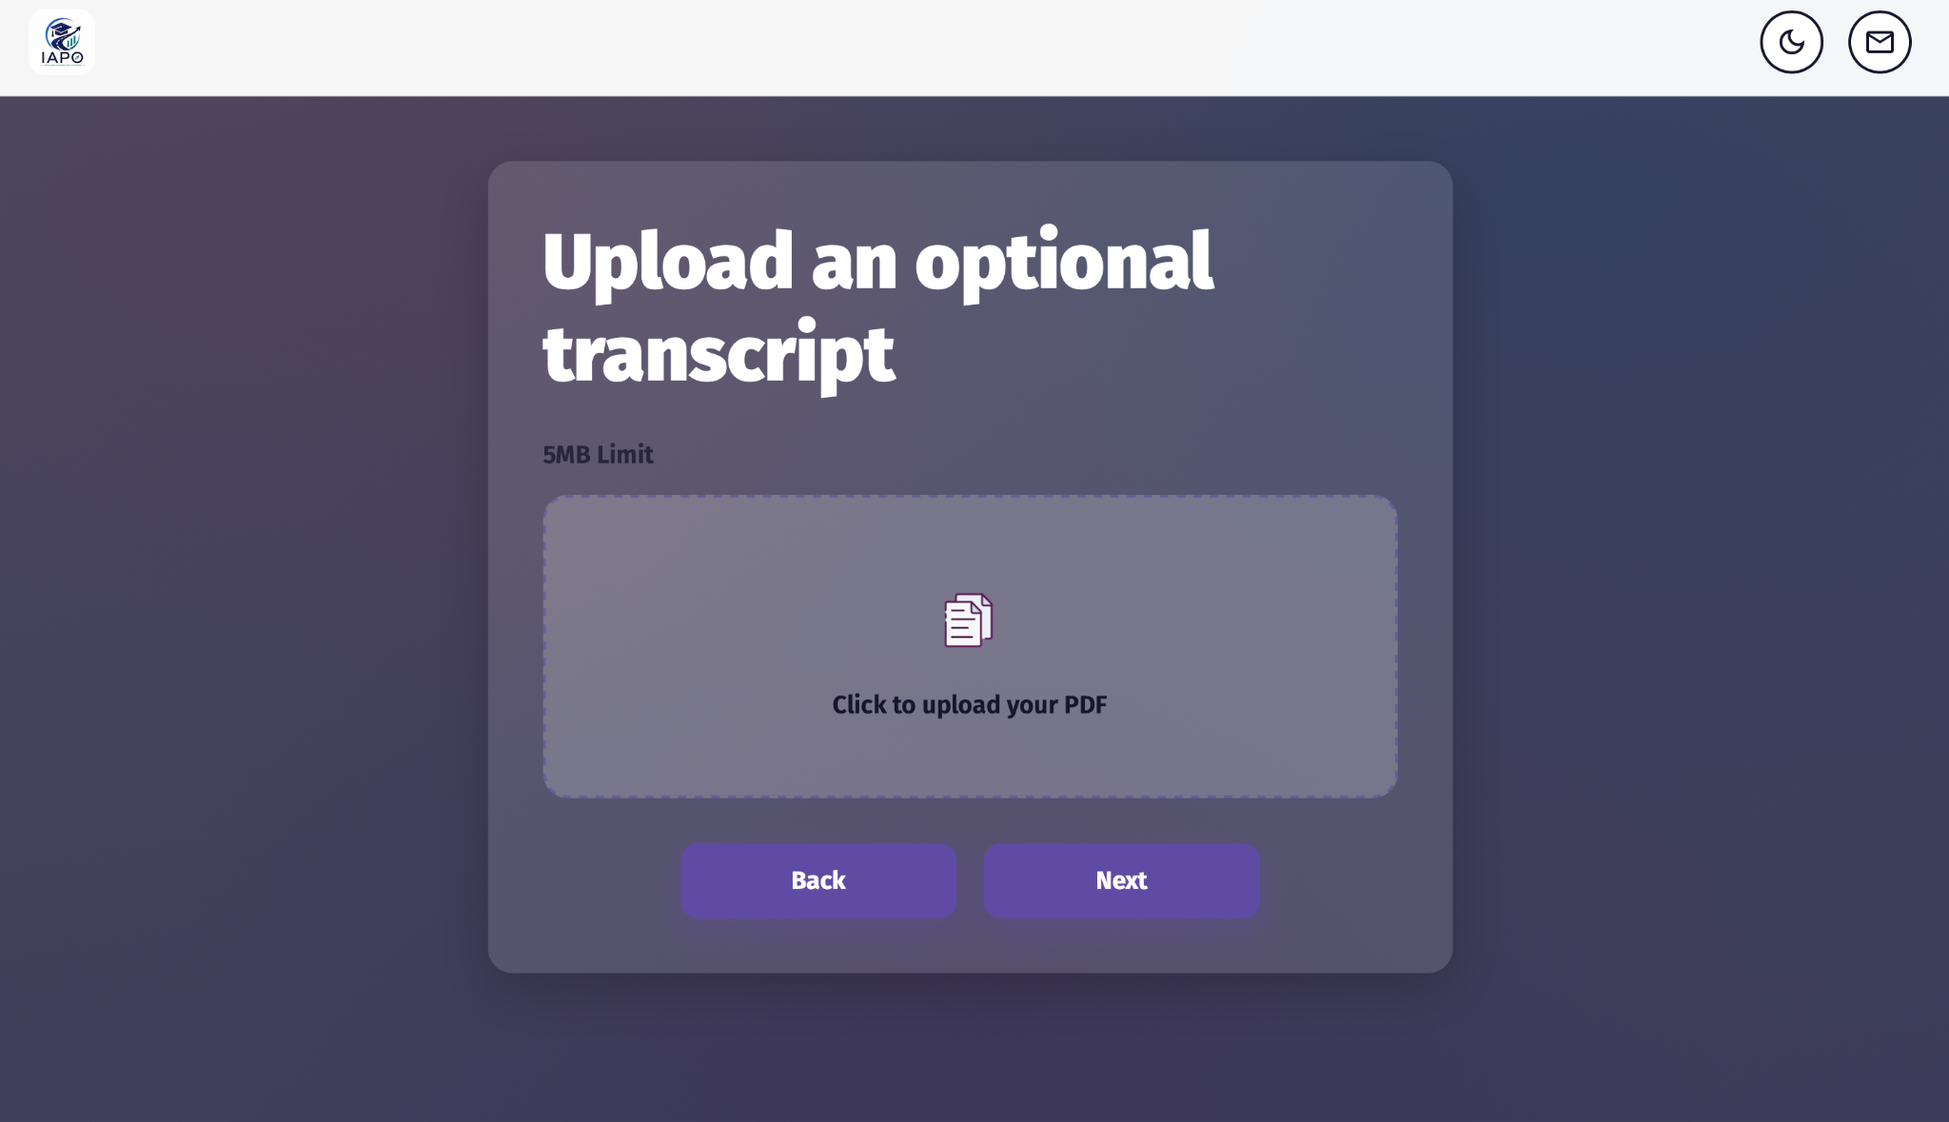

6. Specify What You’re Looking For
The page labelled “Tell us some details” allows the user to directly inform the AI of specific characteristics they wish for their schedule to have. For example, “No gaming courses in the Fall” would be appropriately processed and the expected course plan would be output. When finished, click Generate Plan and you will briefly wait at a loading screen while the schedule is created.

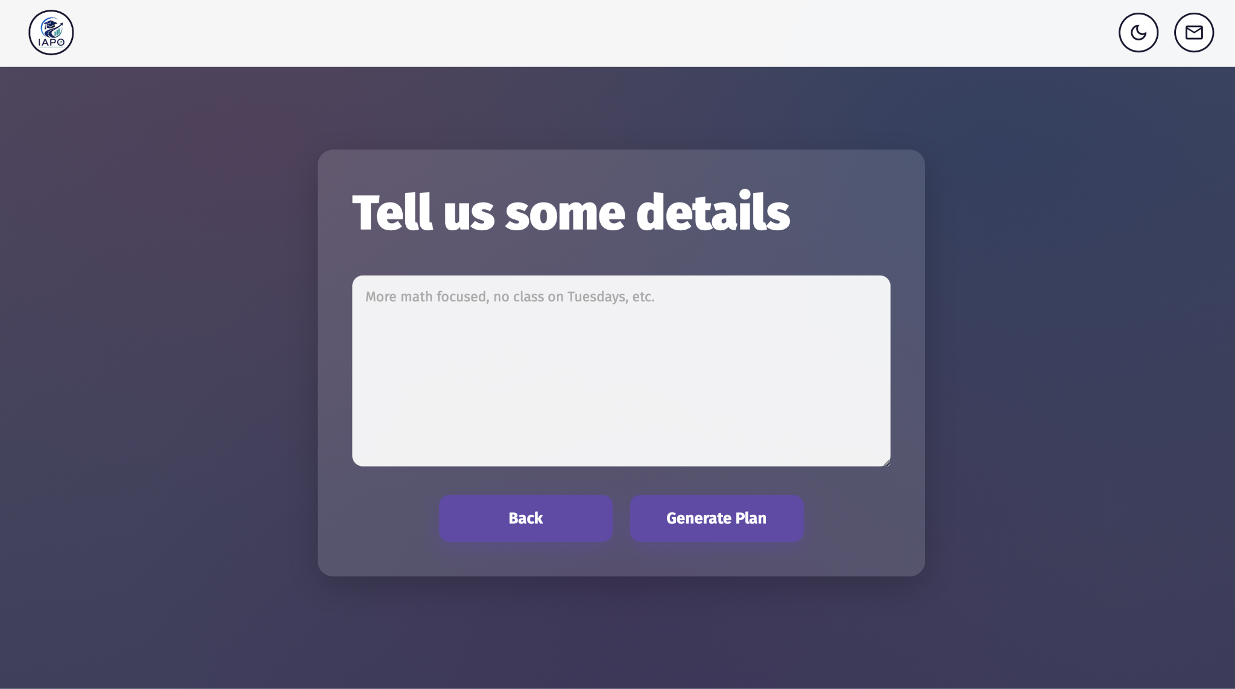

7. Schedule Page
A page similar to the following will be shown.

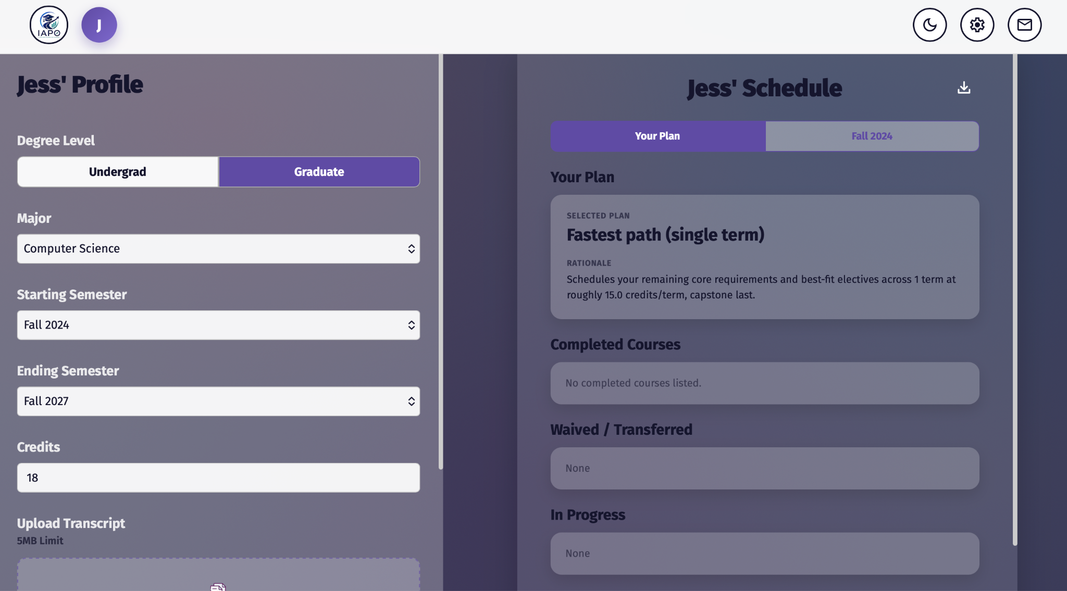

On the left, there is a section similar to the information providing screen in which the user may edit their profile, upload a new transcript, or ask the AI to make changes to the current schedule. Clicking Next at the bottom of this section will generate a new schedule.

The right side of the screen presents the generated schedule with the following sections:

Tabs
The first tab displays the overarching plan information and subsequent tabs display the classes chosen for the corresponding semester.

Your Plan Tab
- Gives an overview of the plan’s focus, reasoning on how the schedule was chosen, and goals that would be reached with the schedule.
- Optionally, if a transcript was uploaded, the user’s previously completed, waived/ transferred, and current semester courses will be displayed.
- Additional notes on schedule generation may be listed

Semester Tab
These tabs will display the suggested classes for that semester. The top right will show the total credits for that semester. Each class will thereunder be displayed with its amount of credits, course code, and why it was chosen.

Download Button
The icon at the top right of the schedule portion gives the option to download the user’s schedule, as seen below.



8. Settings Page
The top right of each page displays several buttons.

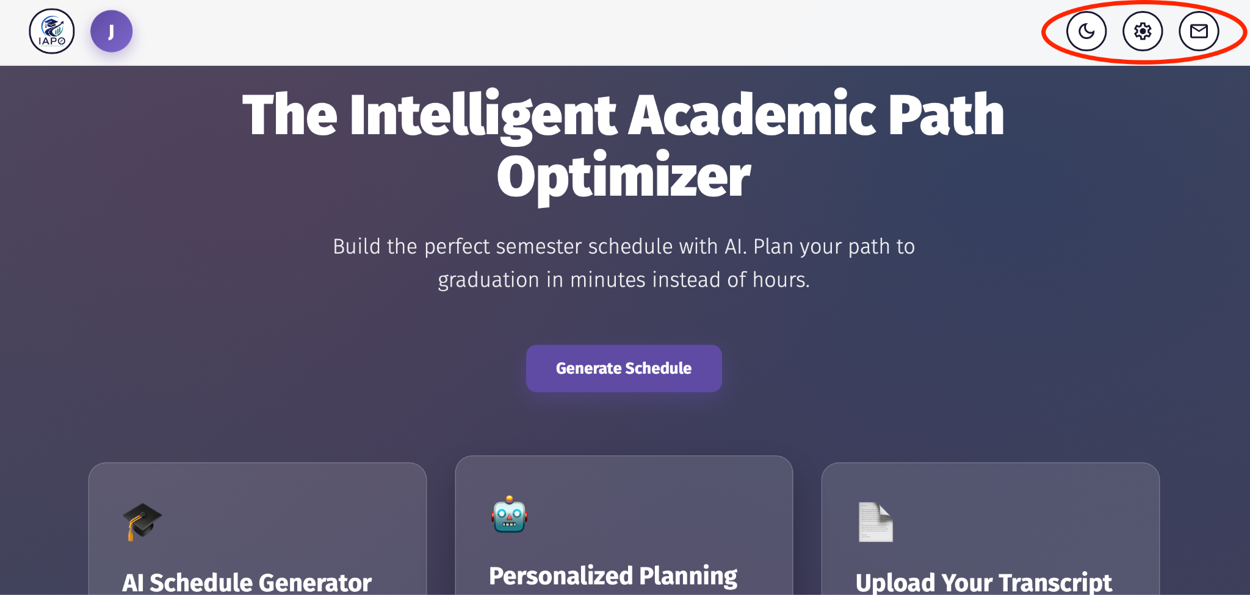

The gear icon will navigate the user to the settings page where they may change their name, email, and password respectively. This is also where the user may go to sign out, using the red button at the bottom of the page.


Pressing the Edit button at the top right of the Settings card will switch the user to an editing mode where they may make these changes. Pressing the Save button at the top right will enact these changes.

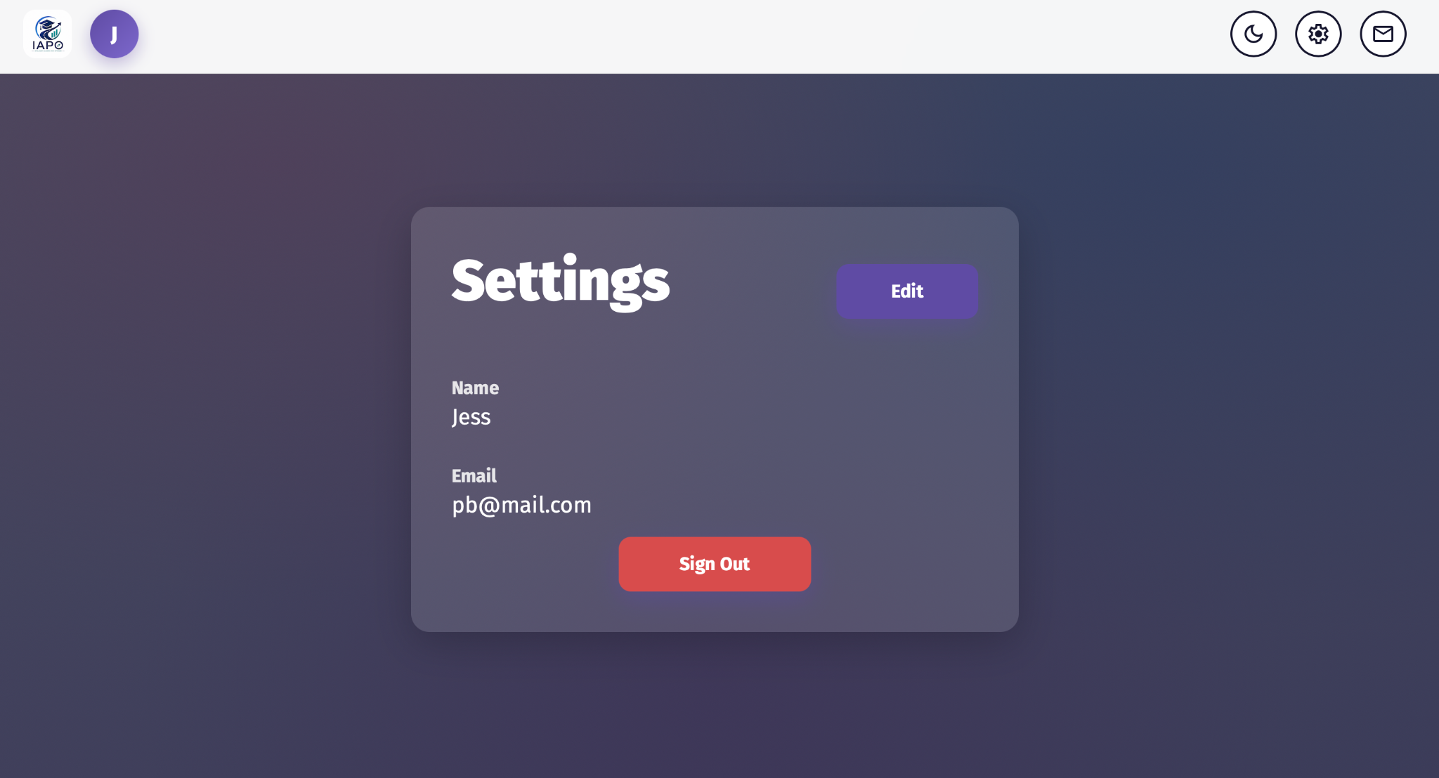

9. Light and Dark Mode
The final button, which shows a moon, allows the user to toggle between light and dark mode.



10. Contact Page
One of the buttons at the top right of each page is also a button depicting a letter. Clicking this will navigate the user to the Contact Page. This can be accessed regardless of if a user is logged in or not.



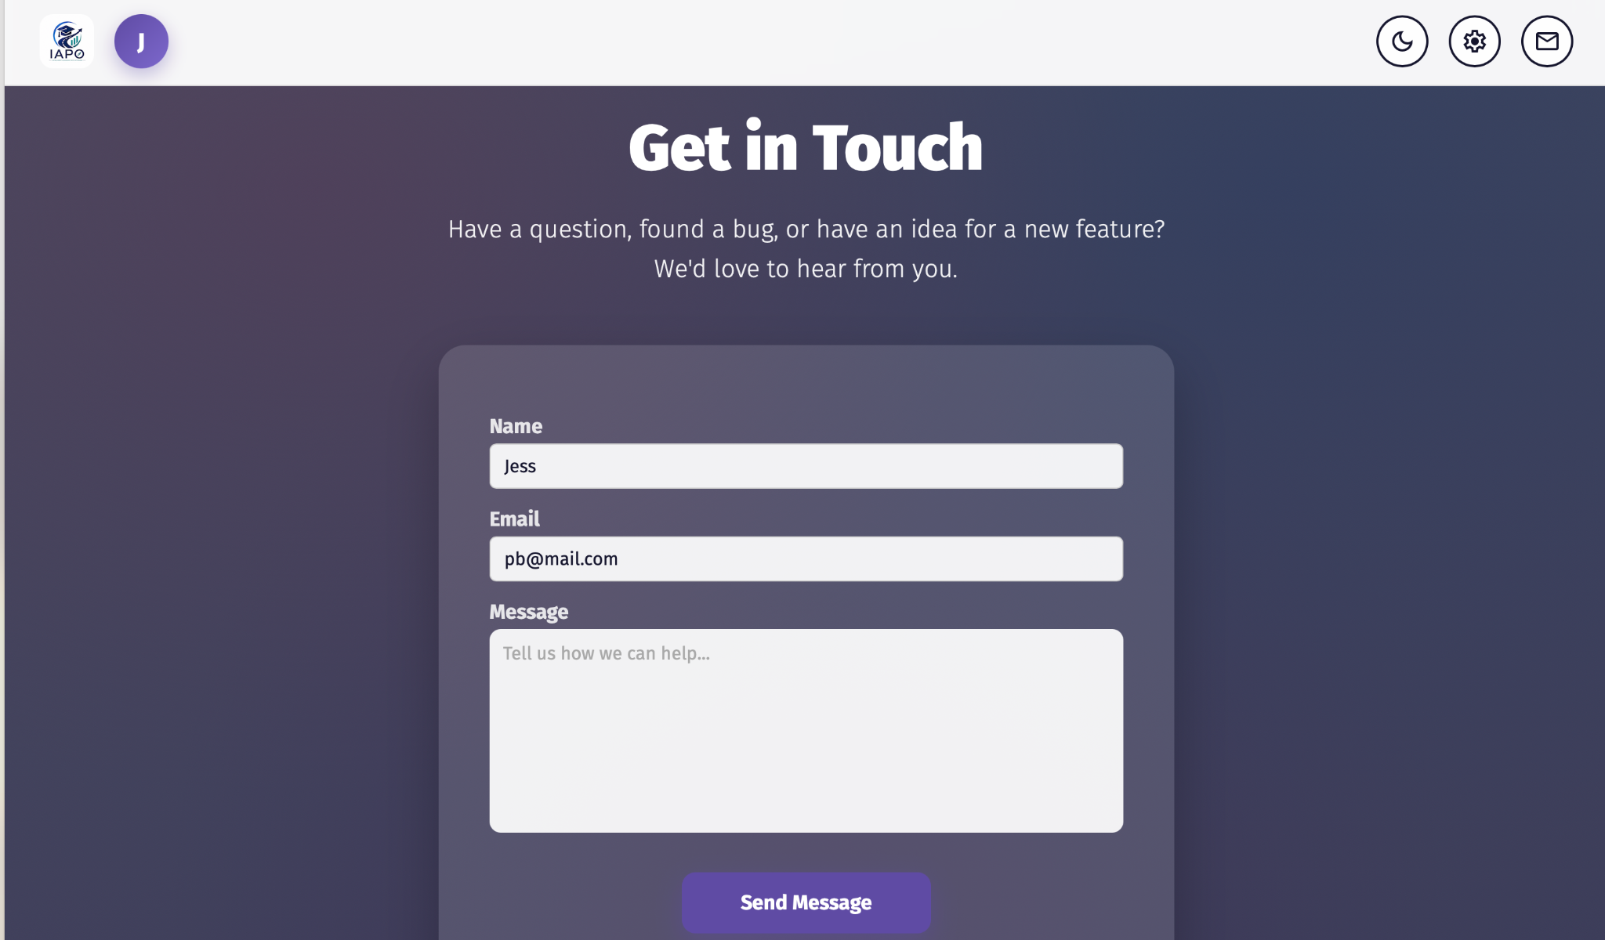
The user’s name and email will be automatically filled in when logged in. The message section can be filled out and clicking Send Message will provide an email directly to the team with this message.

